

Course Code: CBS3005
Course Title: Cloud, Microservices and Applications
Class Number: VL2025260105679
Lab Assessment - 5
Name: Atharva Khachane
Reg No: 22BBS0155

Q. Analyze API Activities using AWS CloudTrail
Description: Enable AWS CloudTrail to monitor and log all API activities in the AWS account. Also, analyze events to detect unauthorized or unusual access.
Initial:
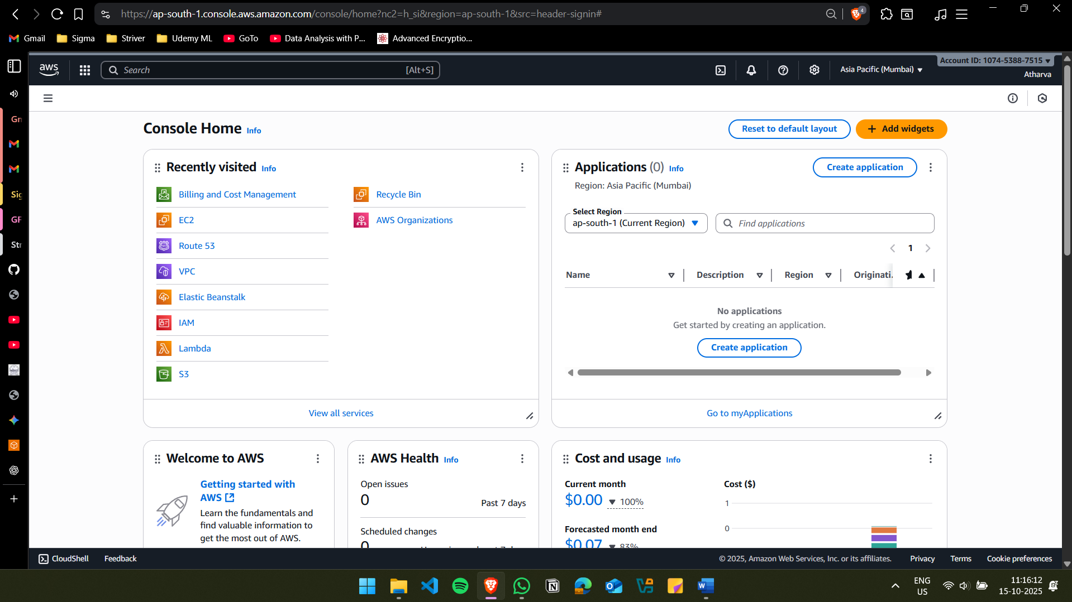

Go to CloudTrail Console → Trails → Create Trail.
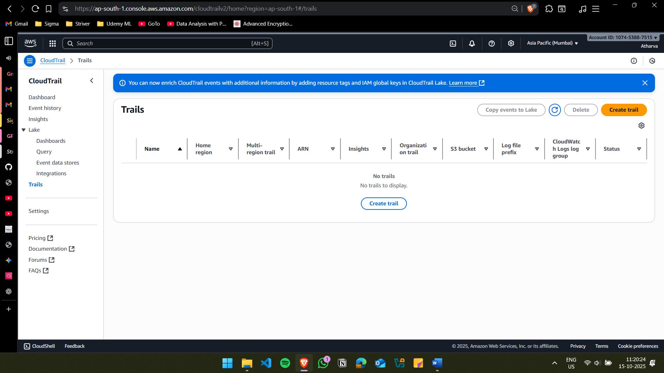

Choose:
Trail name: MySecurityTrail
Apply trail to All regions
Store logs in a new S3 bucket
Enable CloudWatch Logs Integration (optional).
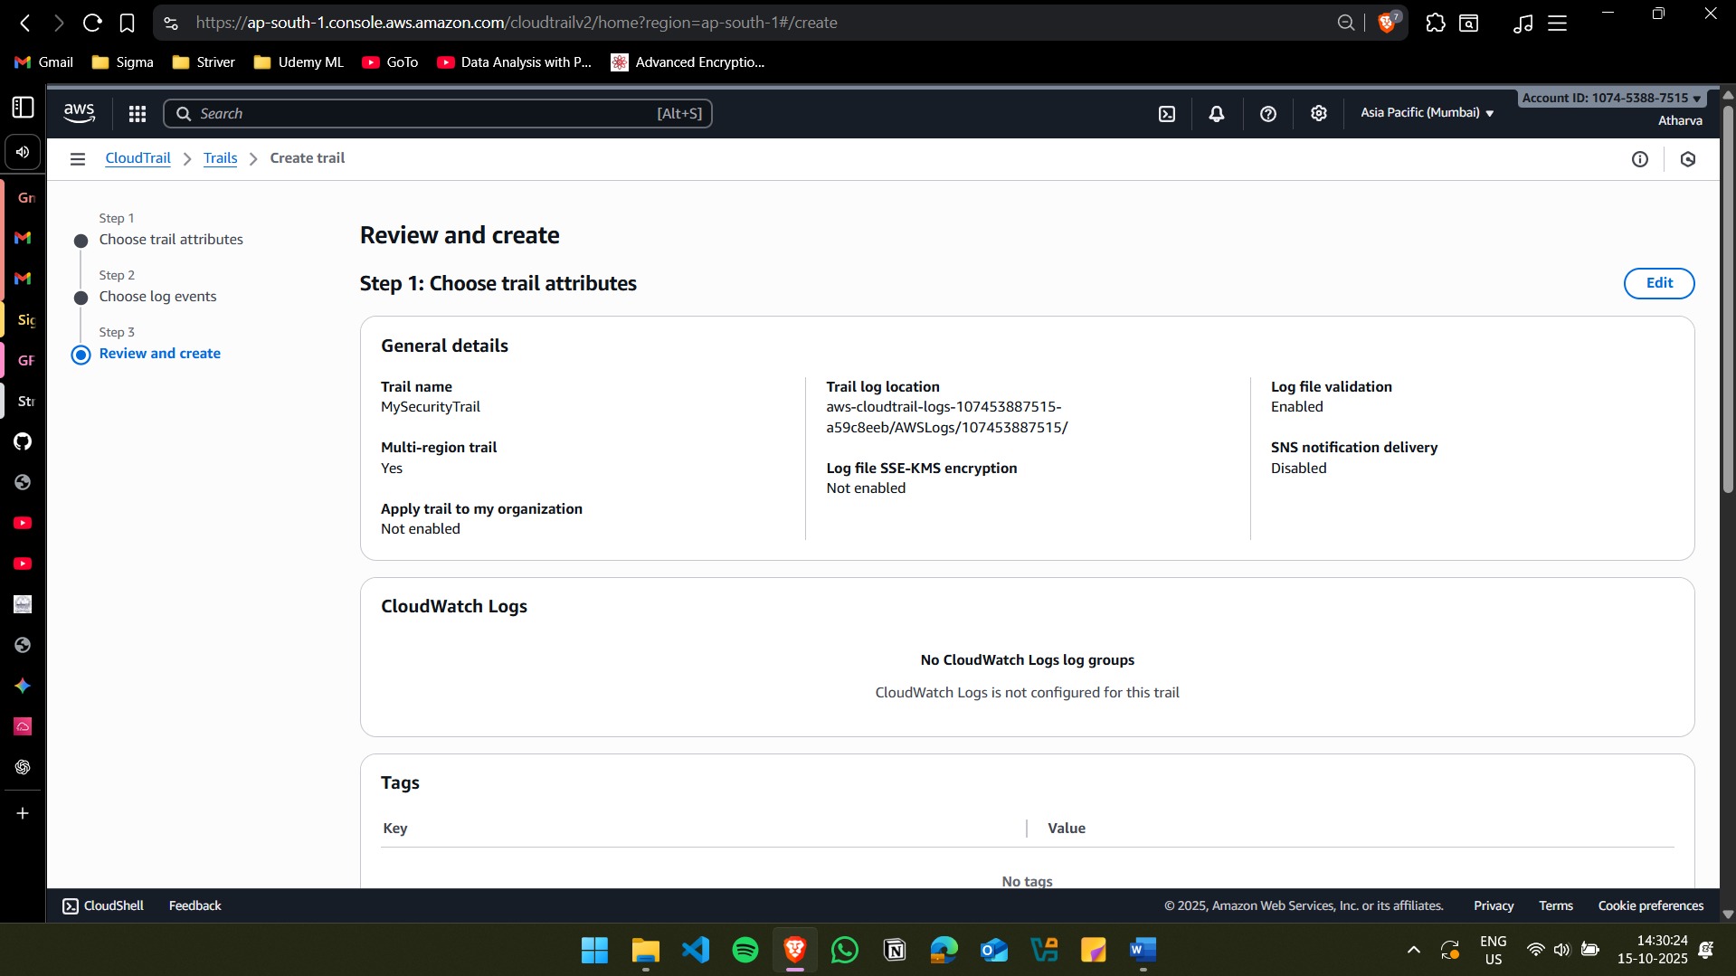
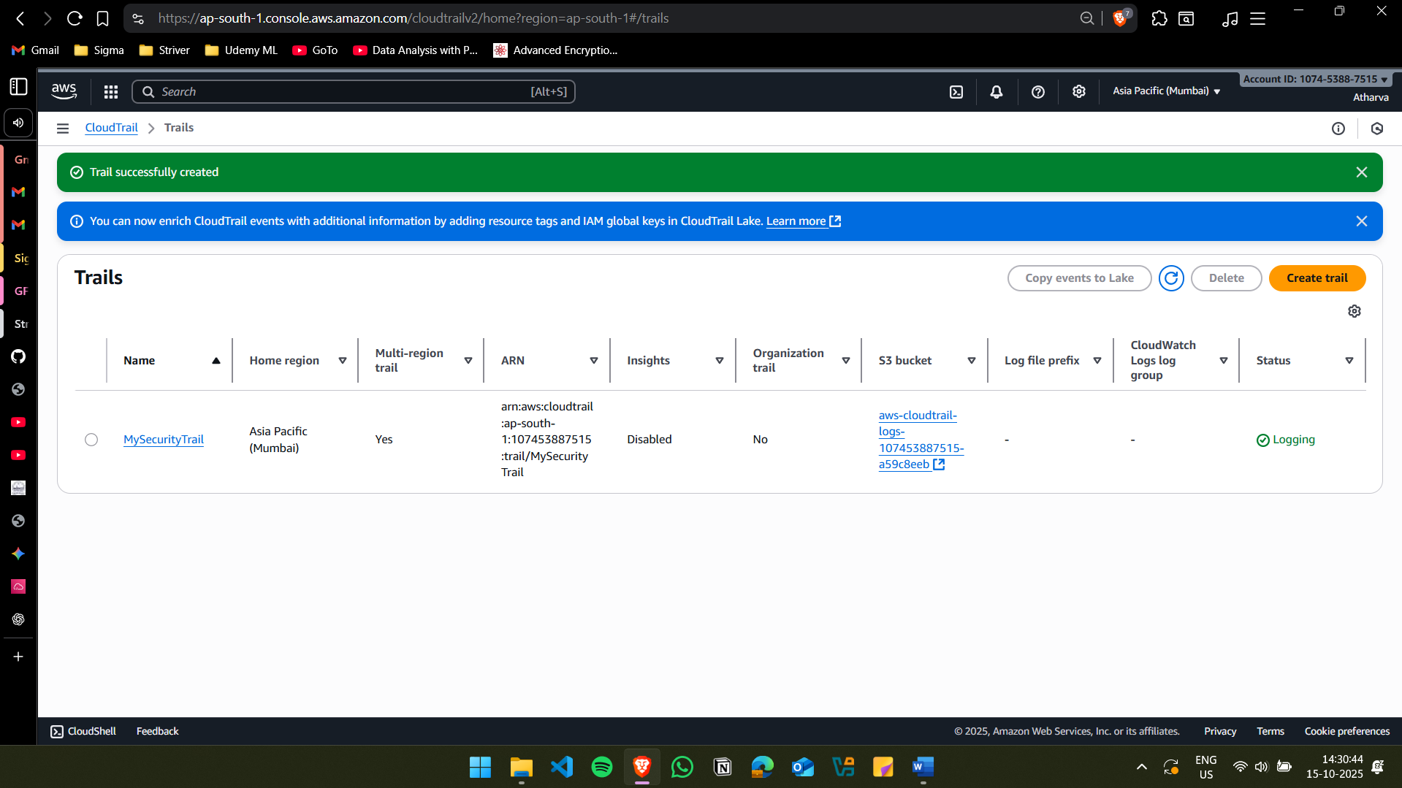

Perform a few activities in your AWS account:
Launch or stop an EC2 instance.
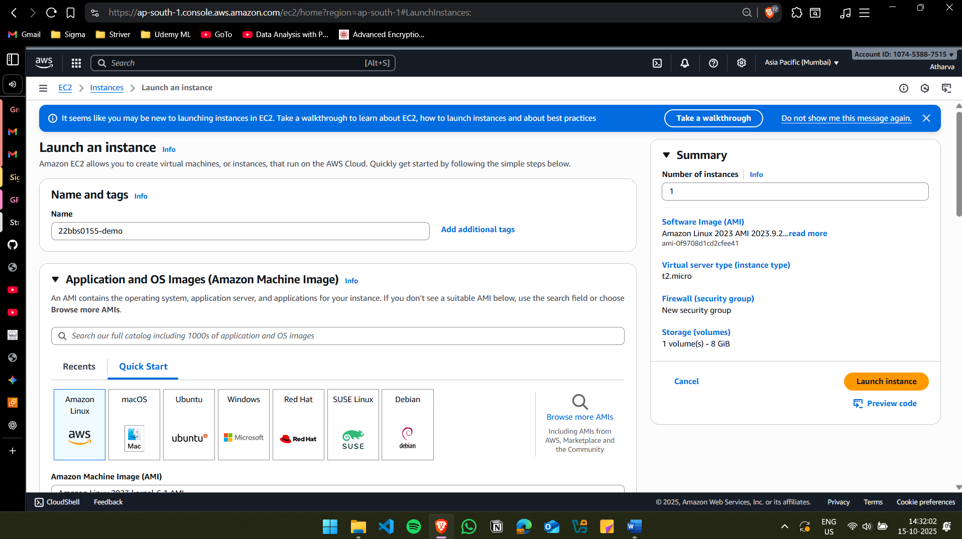
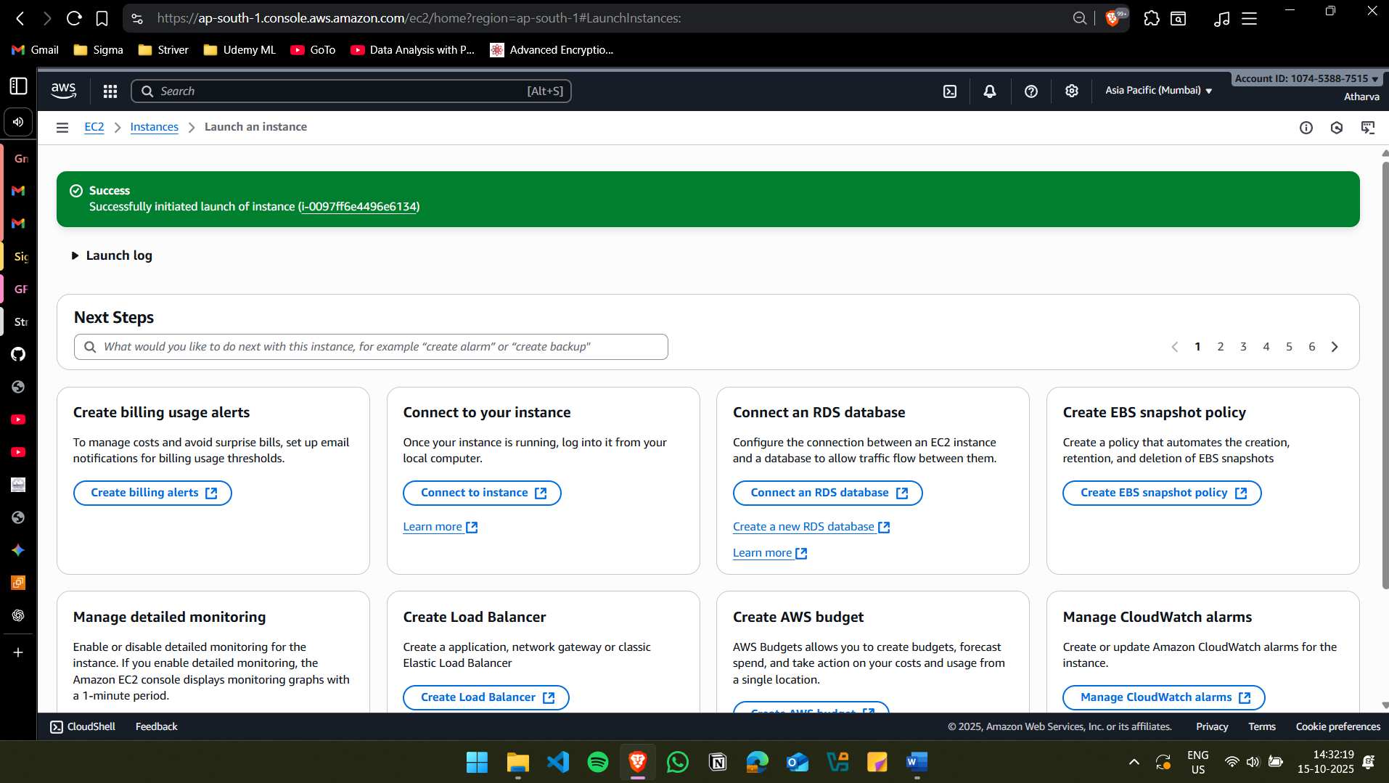

Stop the new instance
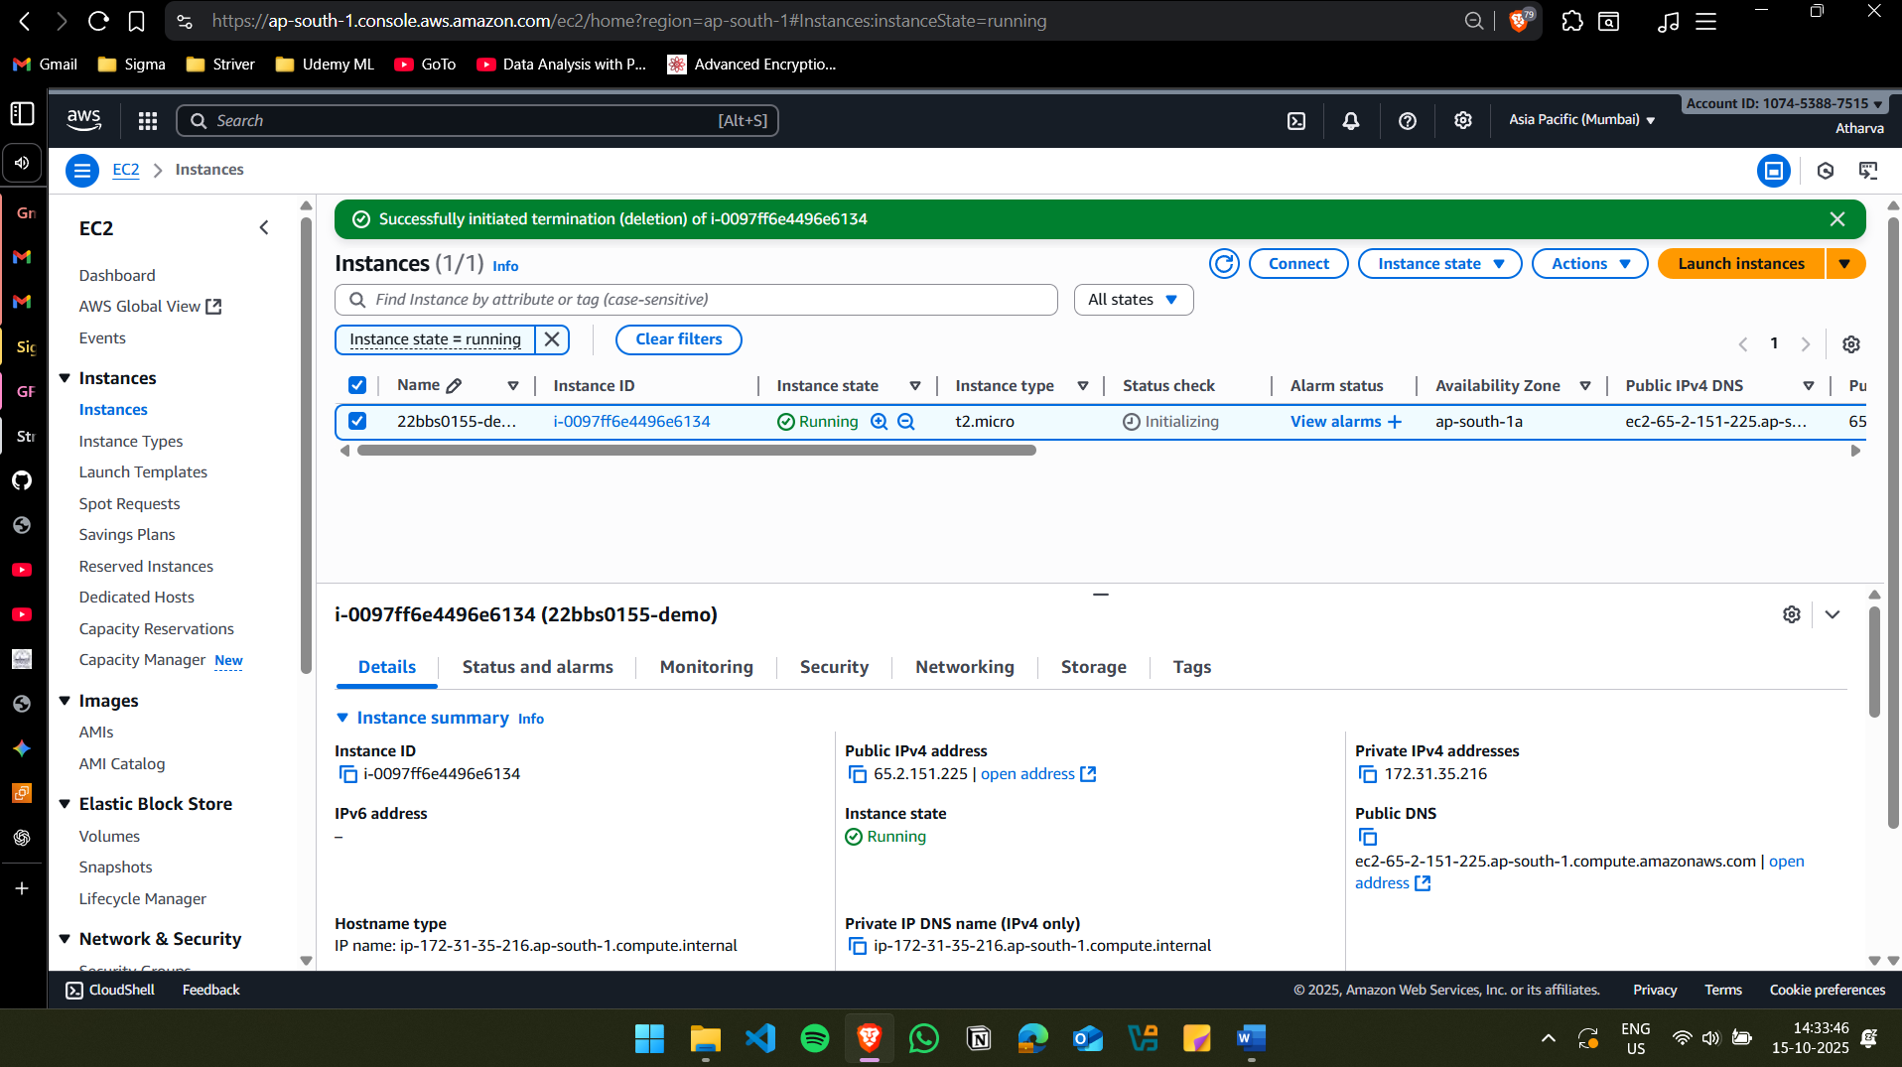
Create an S3 bucket.
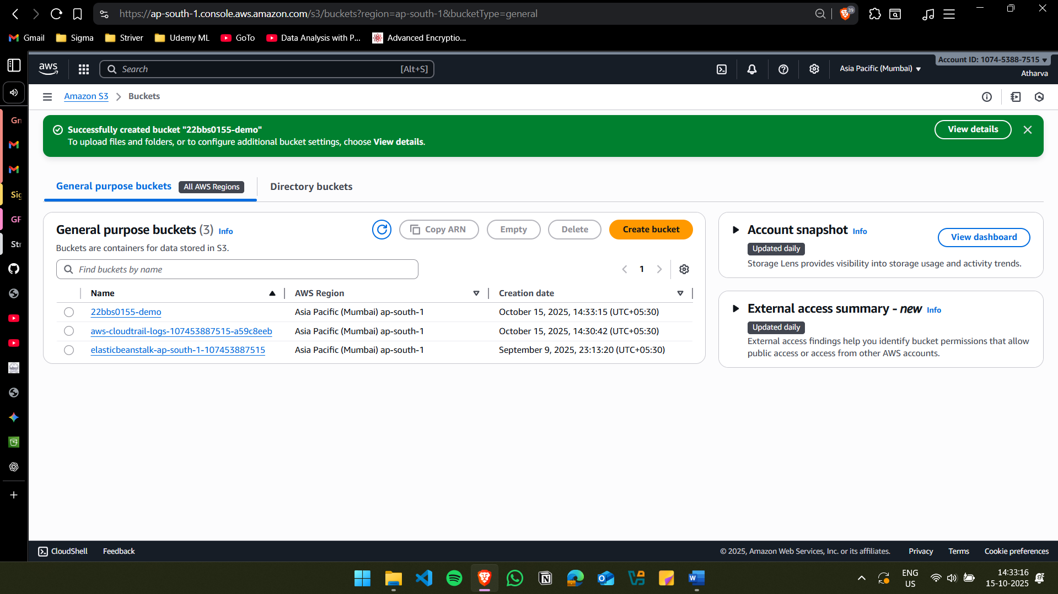

Return to CloudTrail → Event History and view recent events.
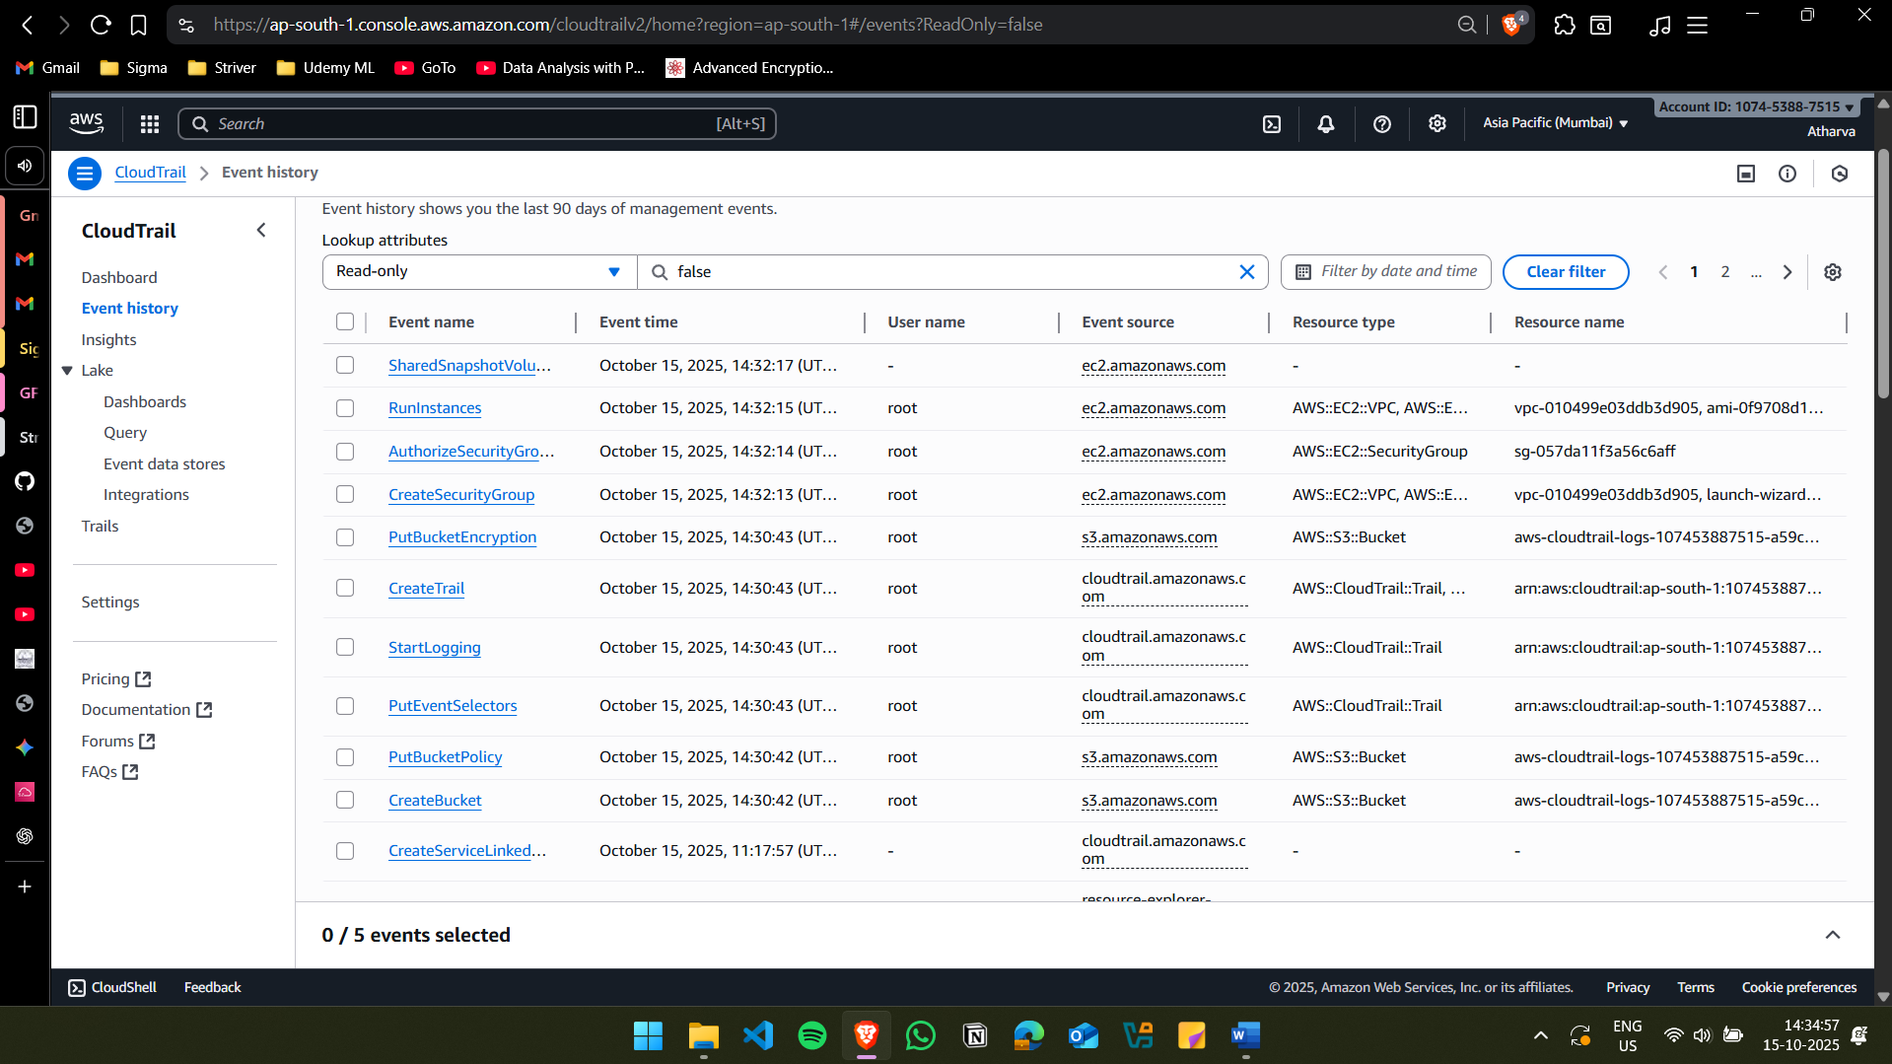

Identify:
Who performed the action (IAM user or role)
Time of action
Source IP address
Affected resource
Following is the example of createBucket event
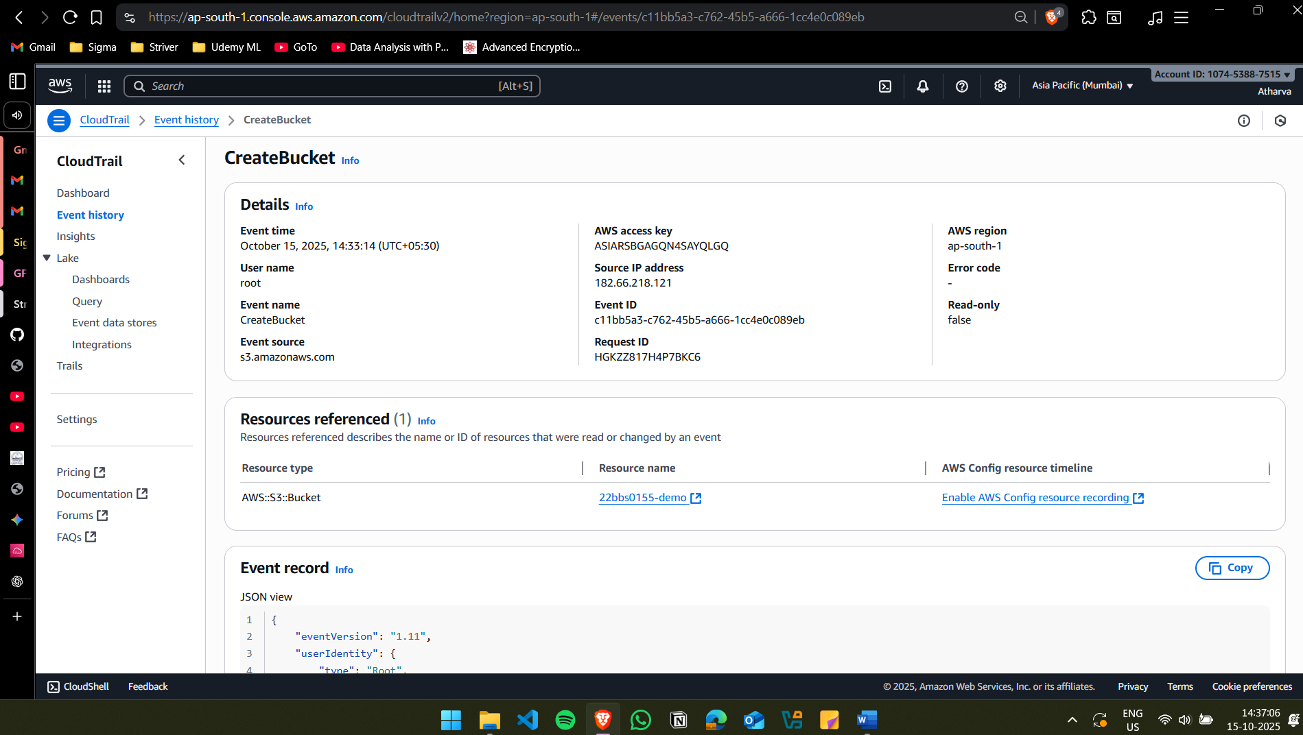
Q. Configure CloudWatch for EC2 Instance Monitoring
Description: Create and monitor a simple EC2 instance using Amazon CloudWatch , configure alarms, monitor system metrics, and analyze performance data to understand how CloudWatch helps in proactive threat and performance monitoring.
Launch a t2.micro EC2 instance (Free Tier eligible) running Amazon Linux 2.
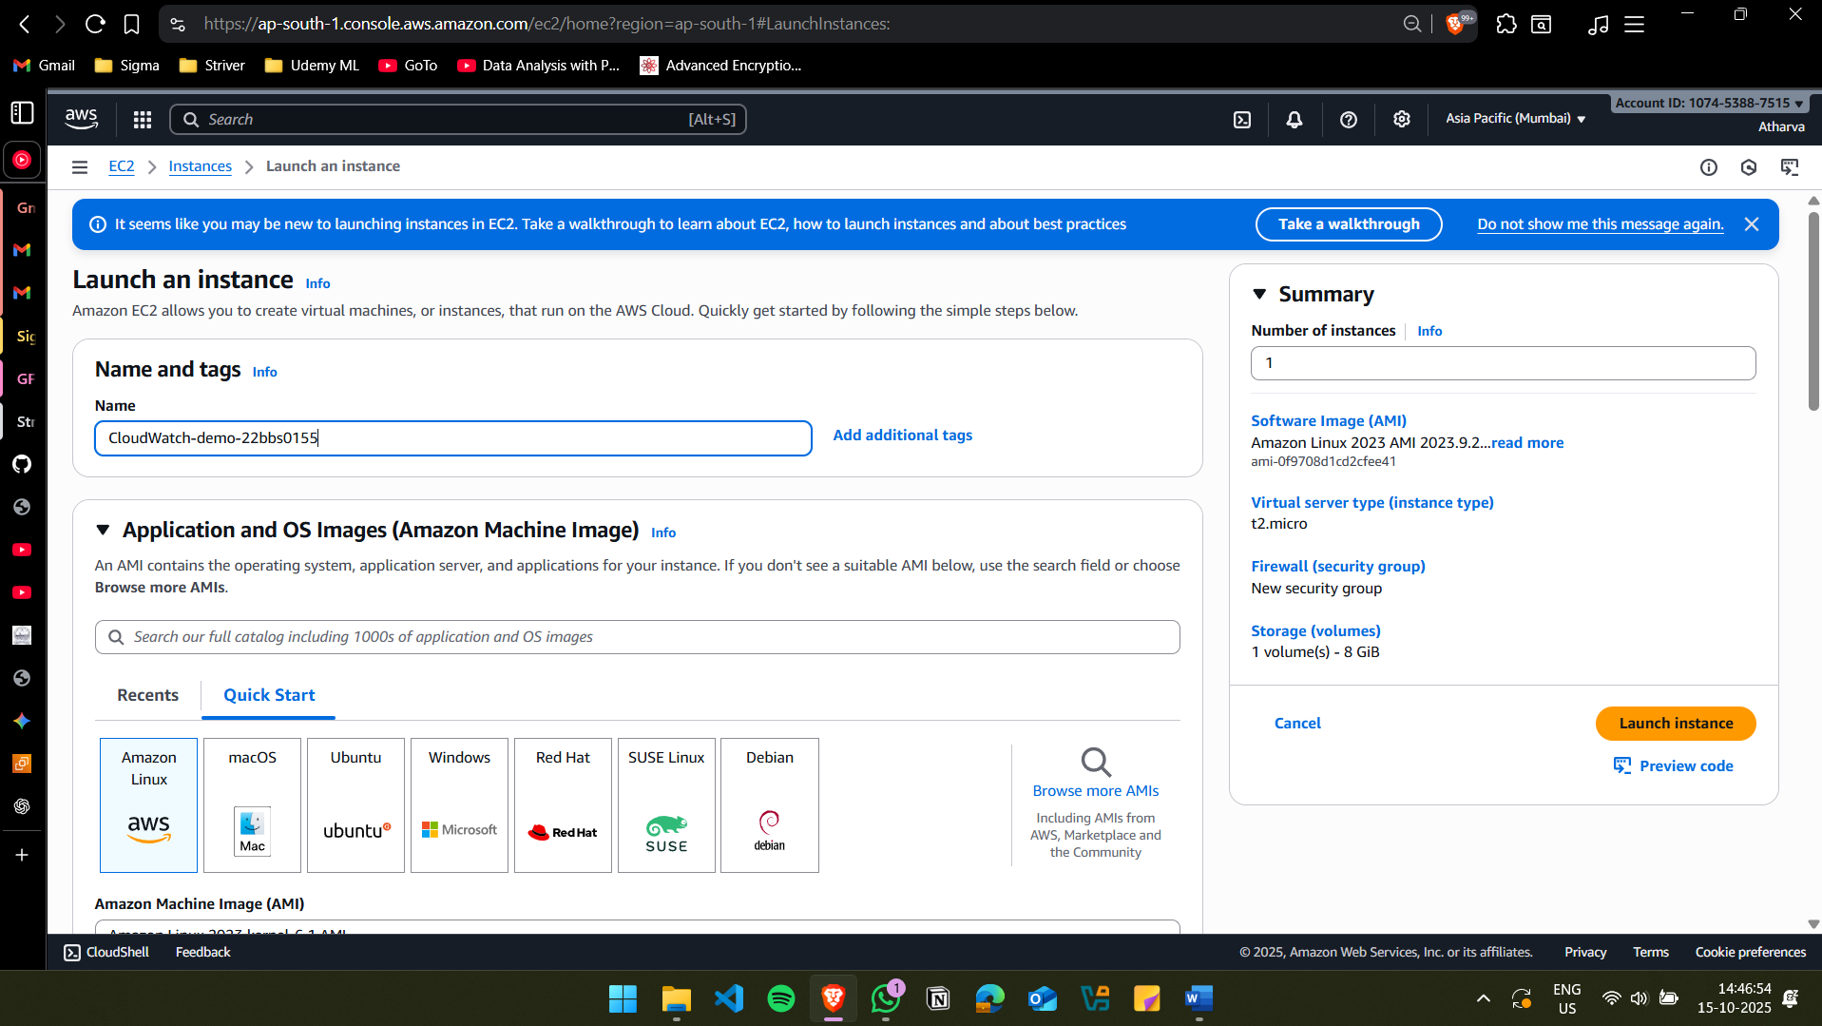
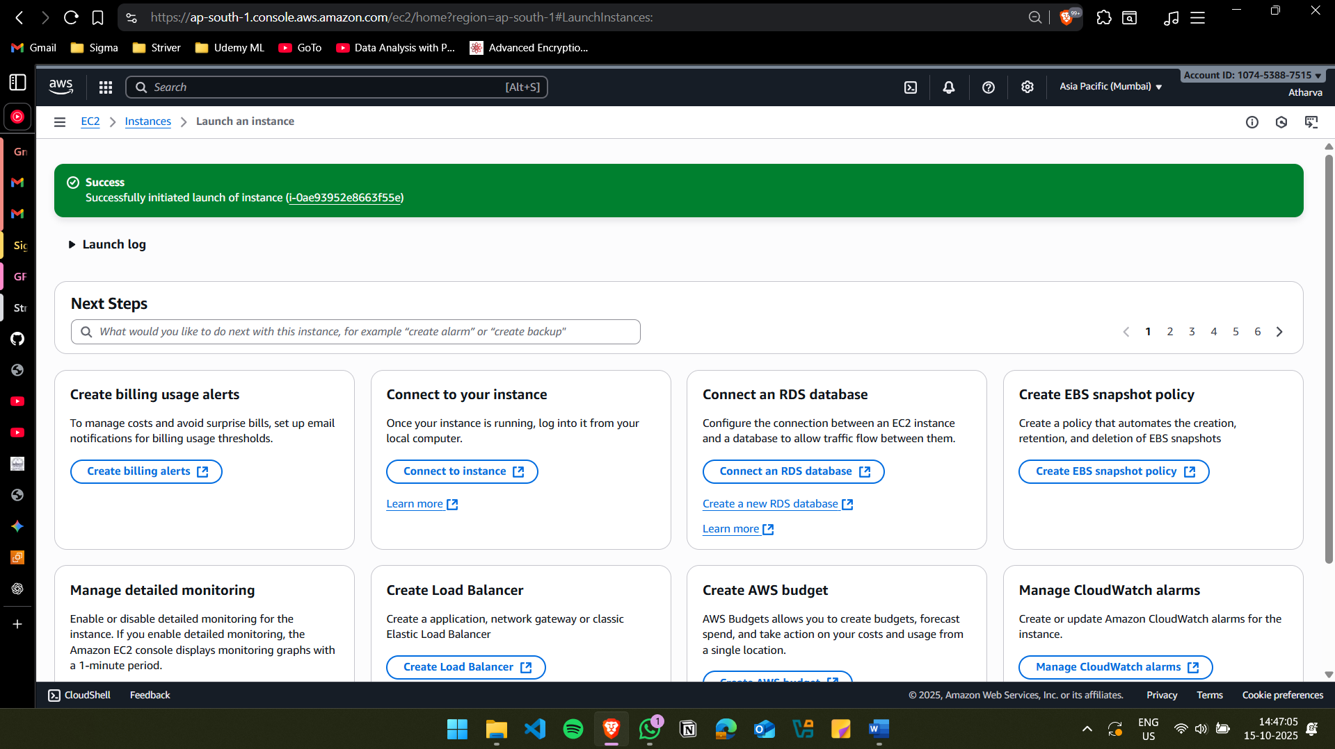

Install and configure the CloudWatch Agent using:
sudo yum install amazon-cloudwatch-agent -y
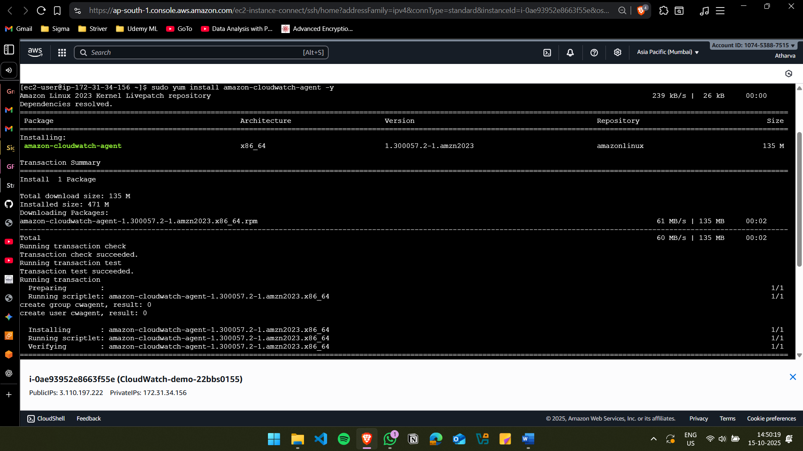
sudo /opt/aws/amazon-cloudwatch-agent/bin/amazon-cloudwatch-agent-config-wizard
Choose to monitor:
CPU utilization
Memory usage
Disk I/O

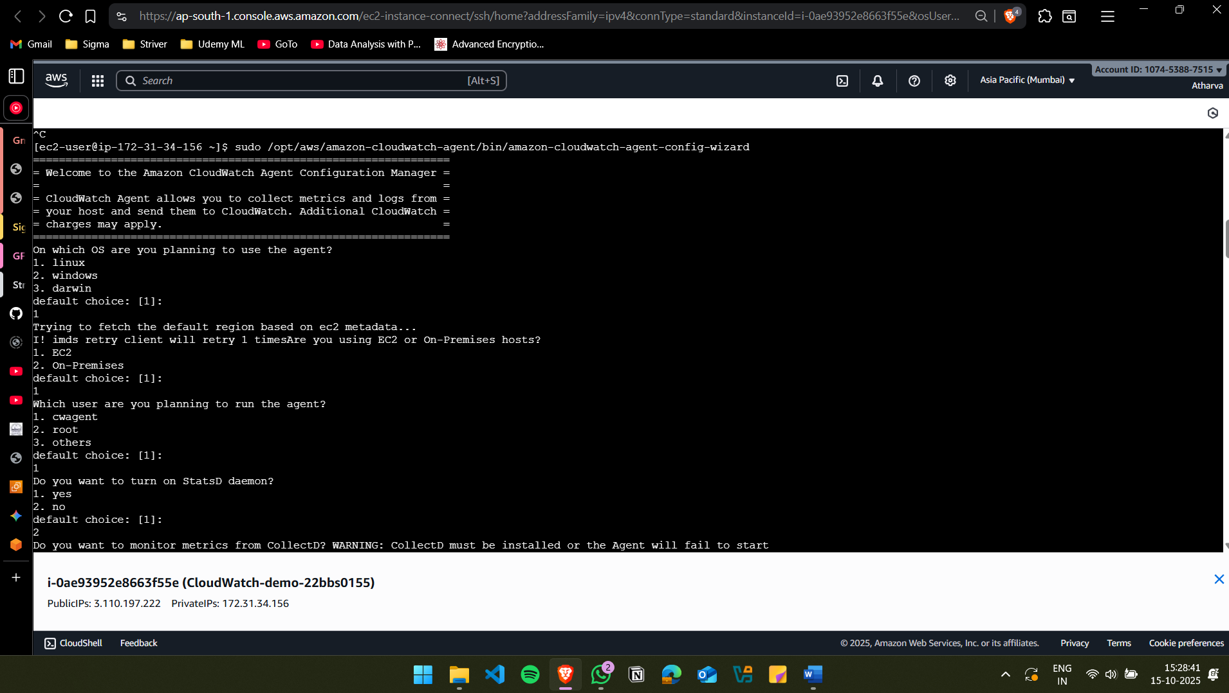
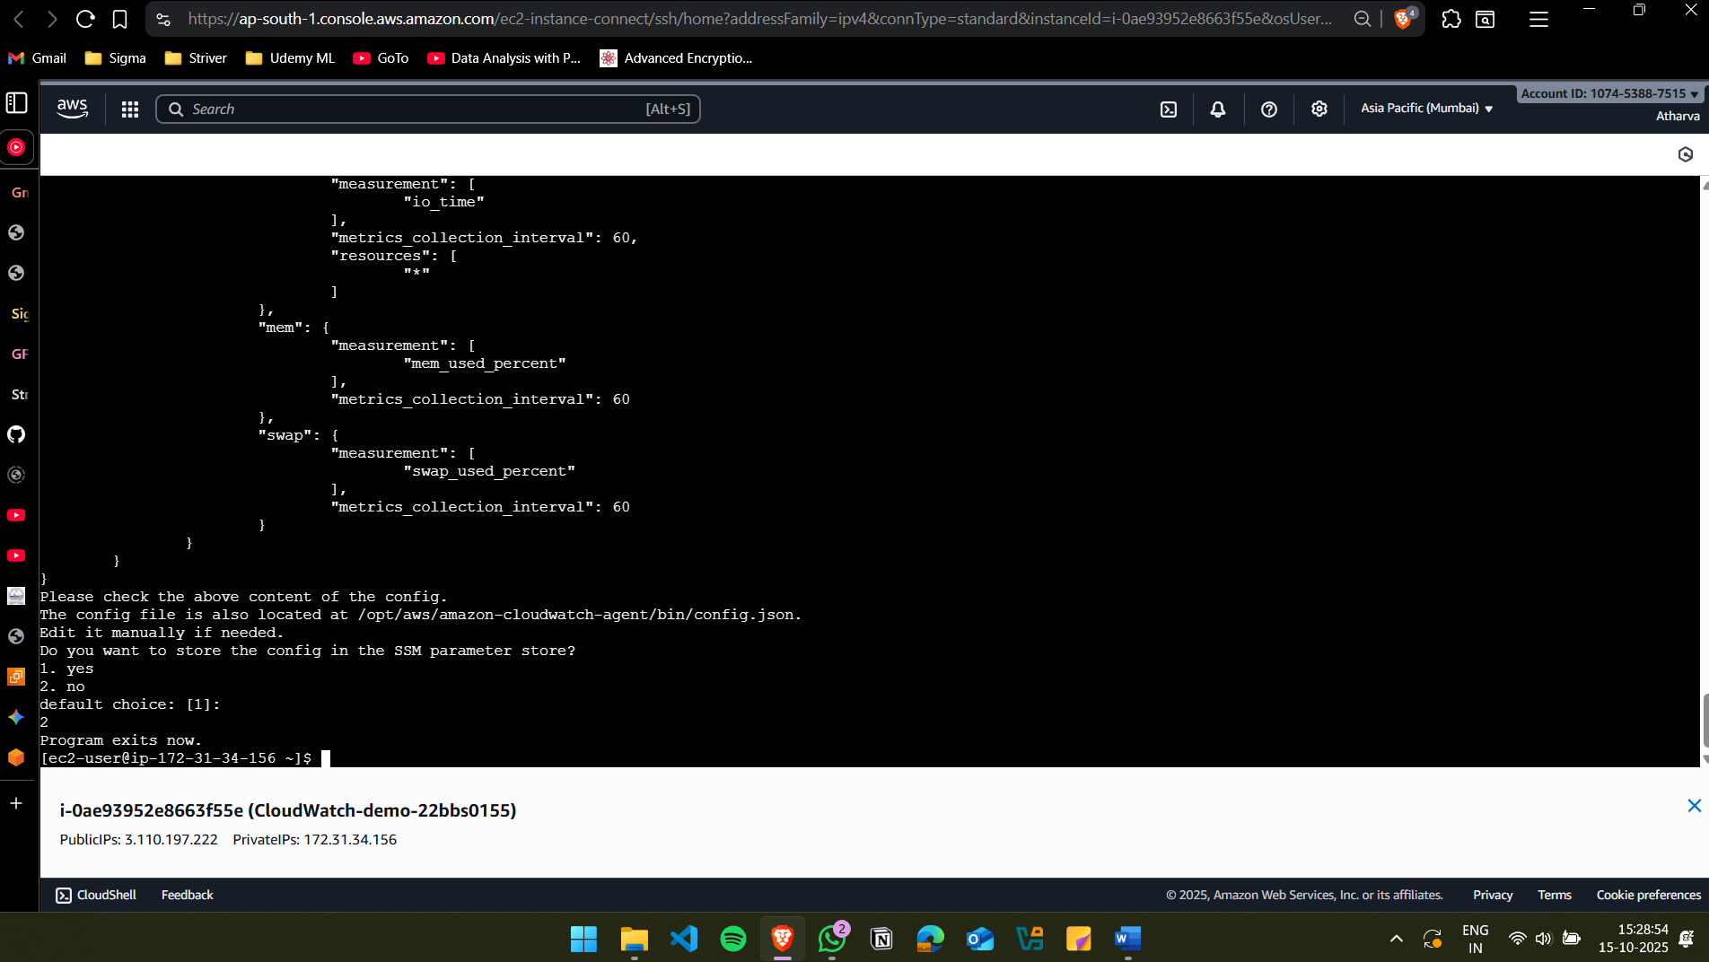
Start the CloudWatch agent:
sudo /opt/aws/amazon-cloudwatch-agent/bin/amazon-cloudwatch-agent-ctl \
-a fetch-config \
-m ec2 \
-c file:/opt/aws/amazon-cloudwatch-agent/bin/config.json -s
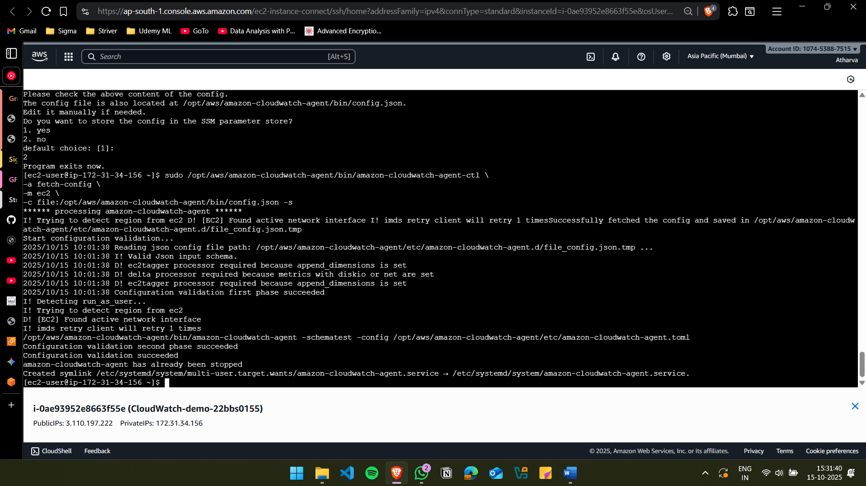

Go to CloudWatch Console → Metrics → EC2 and verify data collection.
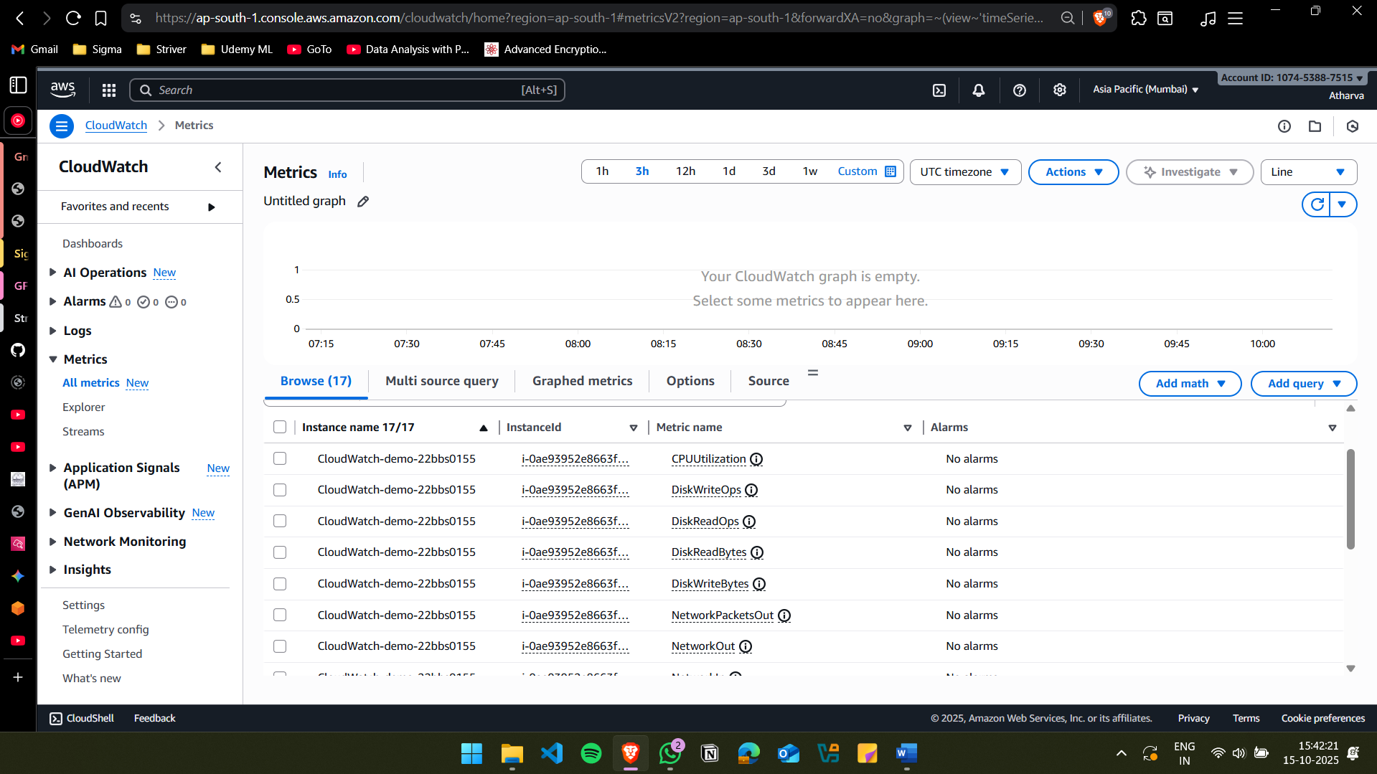
Create a CloudWatch Alarm:
Metric: CPU-Utilization
Condition: >70% for 2 consecutive periods
Notification: via SNS topic (send email alert).
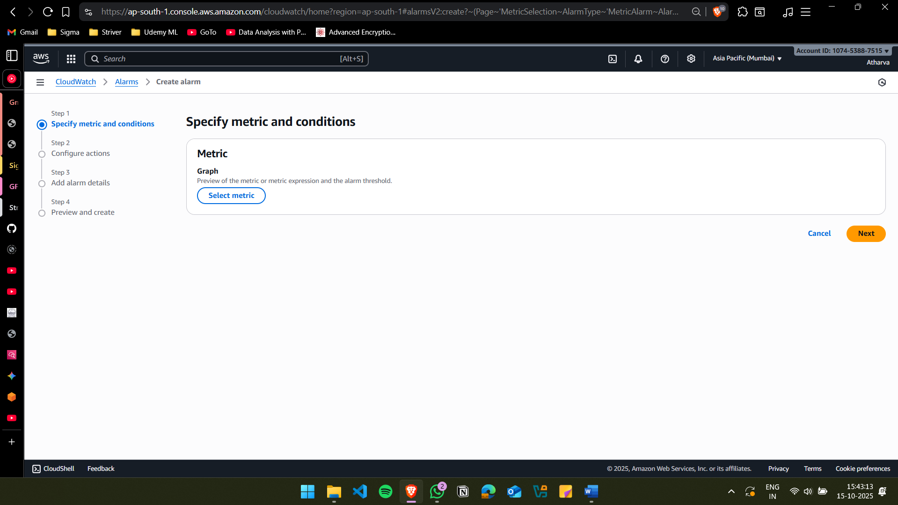

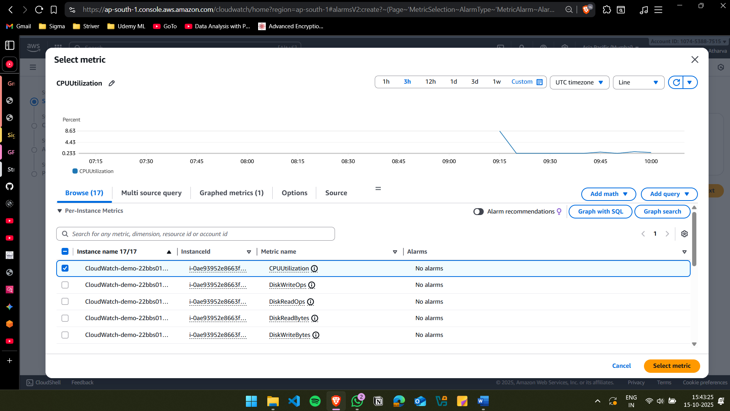

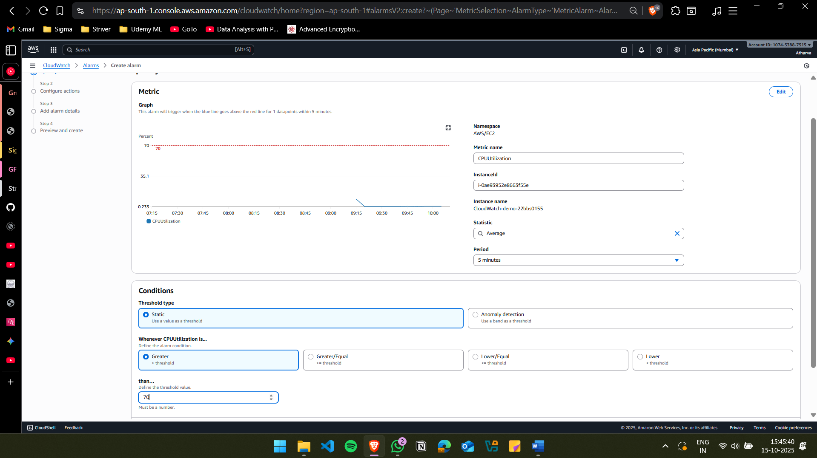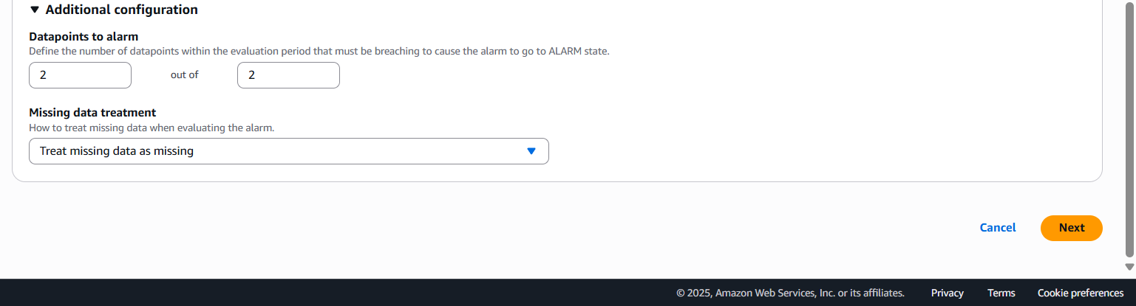
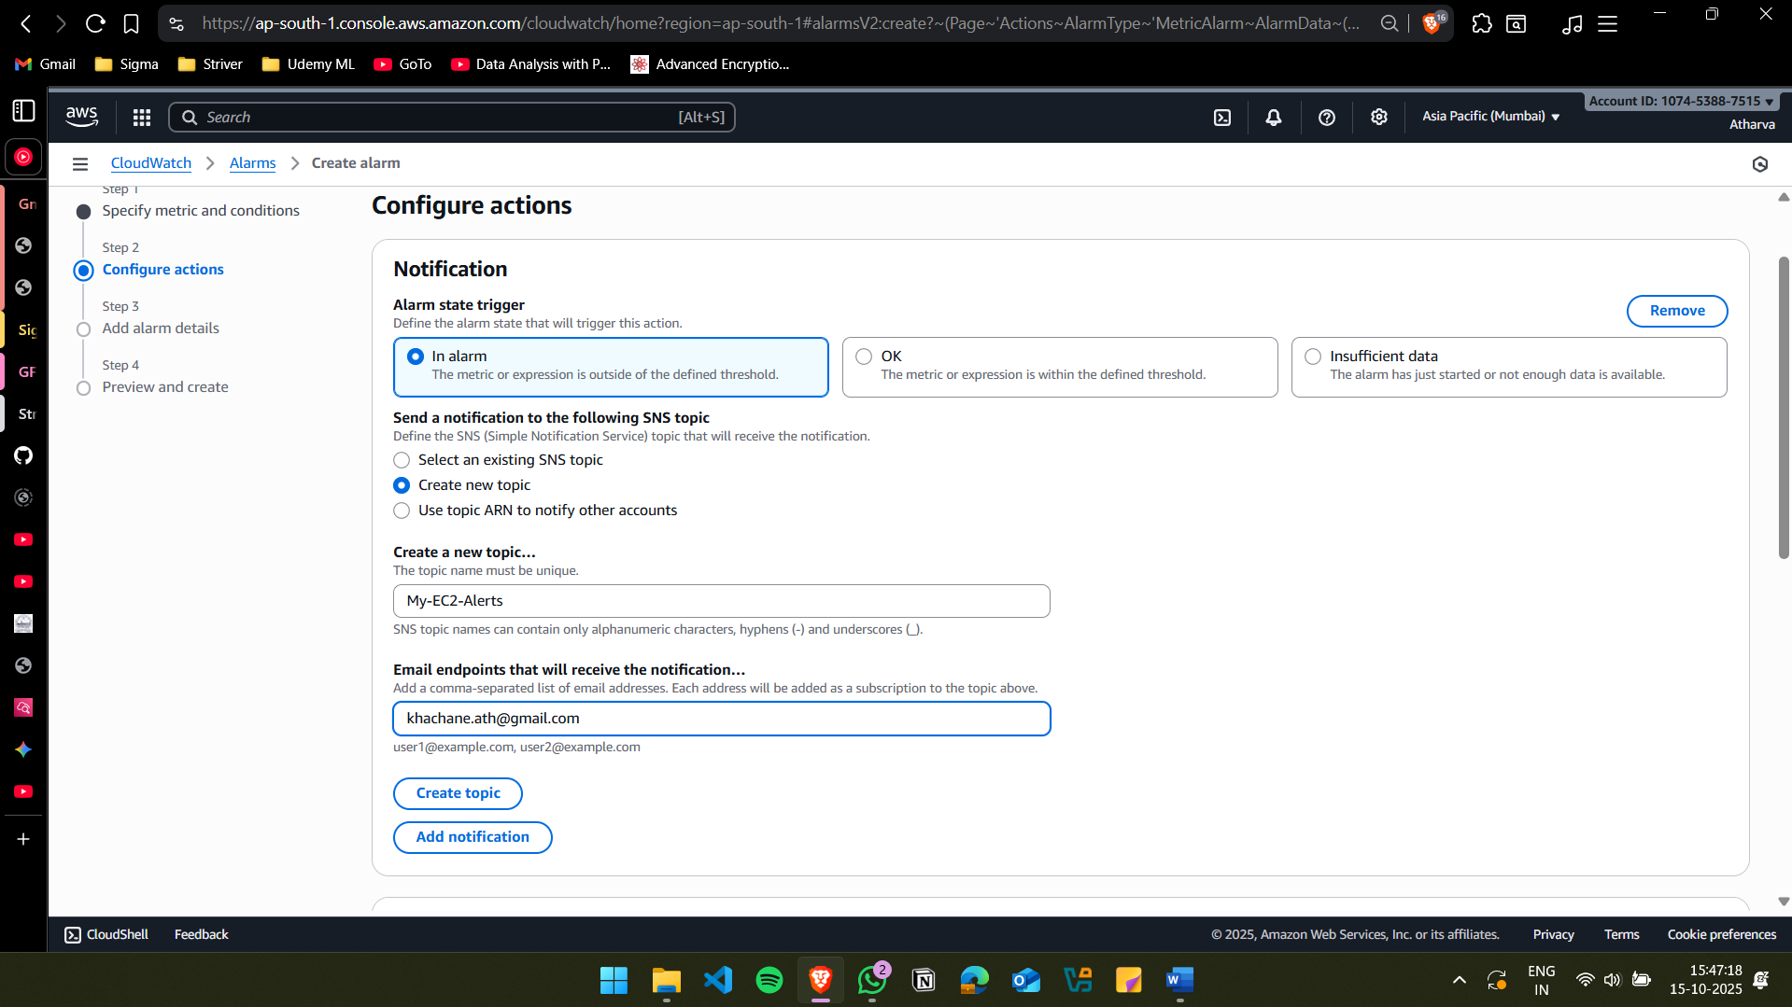 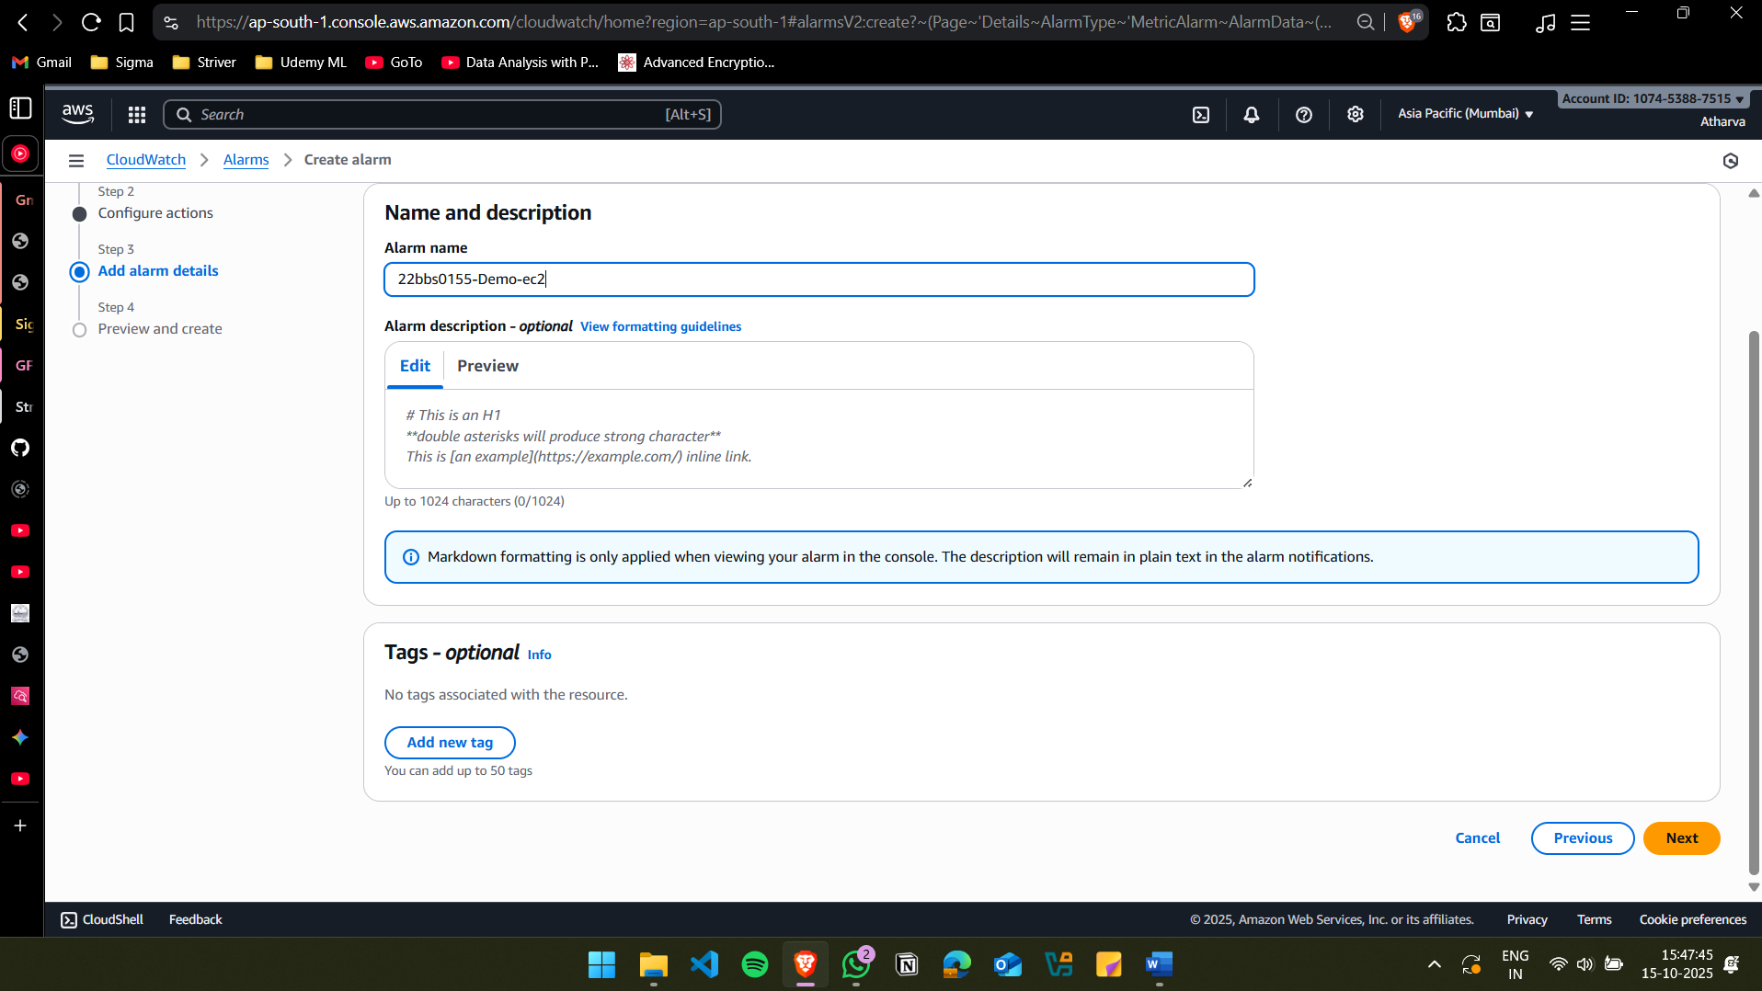 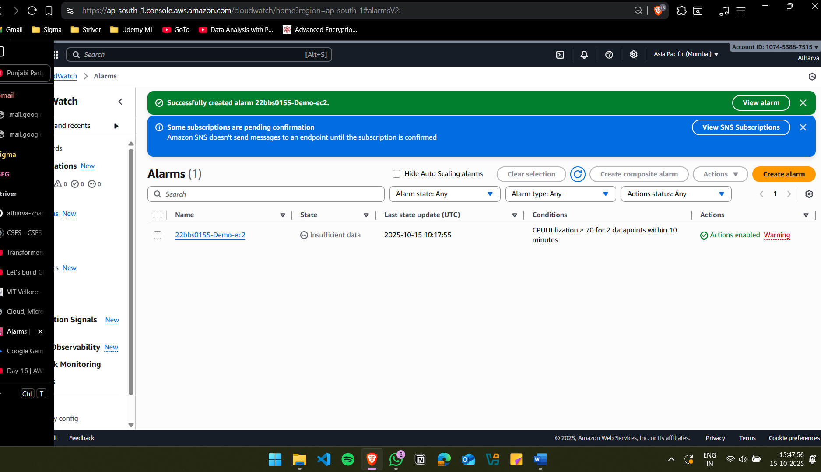ss

